AMIGA ANIMAL RESCUE
Newsletter Series
Newsletter #3, August 2020
Introduction to How to Support Your Senior Cat (and other small animals!) with Acupressure!
Greetings Friends of Amiga Animal Rescue, and welcome to our third newsletter! If you have misplaced our earlier issues, please see our website www.AmigaAnimalRescue.com. Newsletters #1 and #2 are posted on the top banner.
In our earlier issues we introduced our friend, the master dog trainer, Leroy Williams! Leroy has begun an all-purpose, interactive group Facebook page. If you love dogs, or if you are a dog parent or dog trainer, I highly recommend that you reach out to Leroy and join his newly launched group page, Dogs of Beacon Tips and Tricks, https://www.facebook.com/groups/663102797755302/?ref=bookmarks.
Long-time friends of Amiga Animal Rescue recognize Leroy’s vital role these past months in saving the life and rehabilitating our very challenging rescue, Sierra. We are happy to feature as an additional attachment to this email, a link to a video of Sierra playing, as well as below a very peaceful photo of Sierra (the white Bull Terrier) watching the rain with her friend Dino. Friends of Sierra will recognize the miracle of Sierra’s new life, and how vastly different from the first four horrific years of her life! We believe in miracles at Amiga Animal Rescue!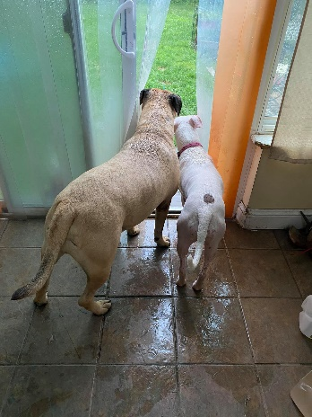

You will find instructions on how to join the Dogs of Beacon, Tips and Tricks located at the top of the group page - basically just sign up with your Facebook address as directed at the top of the group page. You will be glad you did! In addition to his own timely training videos, both live and recorded, Leroy often shares training videos from colleagues. Additionally he is sure to post plenty of happy “just some dogs” moments that will bring smiles!
While there is nothing like dogs to bring smiles – our current newsletter focuses on the other four-legged, furred wonder-being that is a bit more complicated than dogs – cats! And, especially, I am going to introduce you to a very special cat, one of Amiga’s very own rescues, Millhauser, our in-house senior cat who is starting to show symptoms of “old age kidney” disease. (Most of the information in this newsletter, though focusing specifically on how we supported Millhauser the cat’s health conditions, is also useful in supporting health conditions of dogs and other small animals.)
At Amiga Animal Rescue, we try to integrate natural healing modalities into our daily routine as much as possible, which is helpful especially during the kind of challenging time in which we now find ourselves. It is very helpful for pet parents to gain wisdom and ability in the basics of preventative natural healing methods, such as diet and massage, as well as learn to apply safe and easy natural methods to support their pets as the need may arise.
High on the list of natural healing modalities, we prioritize nutrition, some supplementation, including veterinary Chinese herbs, and most importantly - acupressure massage. In our history with healing animals, we have found that occasionally a health crisis may be completely turned around by the use of acupressure massage.

The focus of acupressure is to maintain or replenish a harmonious flow of blood and life-promoting energy called chi throughout the body. In accord with TCM (Tradtional Chinese Medicine) concepts, when there’s a disruption in the flow of chi and blood, the internal organ systems are unable to perform their vital functions and the body is apt to become compromised. When the body is compromised, the animal’s immune system is unable to cope with external or internal pathogens and can fall prey to disease. The entire focus of TCM is to support health by preserving the harmonious flow of chi and blood to nourish the entire body. “Nourish” is a key concept here for both humans and animals, as the ability to nourish up front is exceedingly important in maintaining health and happiness.

The ancient Chinese observed and documented (over a period of several centuries) a system of energy in human and animal bodies that are pathways, which run through our bodies. These “meridians” deliver the life force, “chi,” blood and other vital substances to keep the organs running smoothly.

There are 12 Major Meridians and two Extraordinary Vessels that run just beneath the skin. Each of the 12 meridians –which are bilateral — are named after the internal organs to which they are connected. We are able to influence the flow of chi and blood along these meridians because they have “pools” of energy called “acupoints” situated along them. By palpating or stimulating these acupoints, we can resolve blockages or stagnations that impede the flow of chi and blood.
Acupoints have particular energetic attributes that influence the movement of chi and blood. For example, the acupoint called Gall Bladder 34 (GB 34 – the 34th acupoint on the Gall Bladder meridian) influences the flow of chi and blood to the tendons and ligaments when it is palpated. We would use GB 34 to nourish those tissues and increase their strength and flexibility.
TCM is best used to prevent illness but is also effective in managing chronic health issues. It has been well documented that acupressure can enhance overall health and emotional stability, in both people as well as animals. Specifically, it can: Build the immune system – Strengthen muscles, tendons, joints and bones – Balance energy to optimize the body’s natural ability to heal – Release natural cortisone to reduce swelling and inflammation – Release endorphins necessary to increase energy or relieve pain – Enhance mental clarity and calm - Resolve injuries more readily by increasing the blood supply and removing toxins.
Now may be the perfect time for you to learn some basic acupressure techniques to support your cat or dog in the ongoing effort of maintaining physical and mental health! Recently we have been successfully using acupressure massage on our senior cat, Millhauser, and we are happy to introduce him to you in this newsletter!
Millhauser, our sweet Tuxedo boy, is beginning to show symptoms of both thyroid and kidney problems. Not all senior cats suffer from this dual challenge, but many do. And, often these organ weaknesses can lead to a most debilitating condition, which requires medication, special diet, and constant sub-q fluids. In terms of Chinese medicine and the location of acupoints, kidney and thyroid issues are often related. So far we have been able to support Millhauser so that he is fully functioning, and even continuing to play, without the need for meds and fluids.
Millhauser, affectionately known as “Milly” is one of the happiest Tuxedo kitties Amiga has ever seen! He came to Amiga with his girlfriend, Delilah, about five years ago. They had originally found each other in a shelter and had become a pair, and they were adopted together from the shelter.
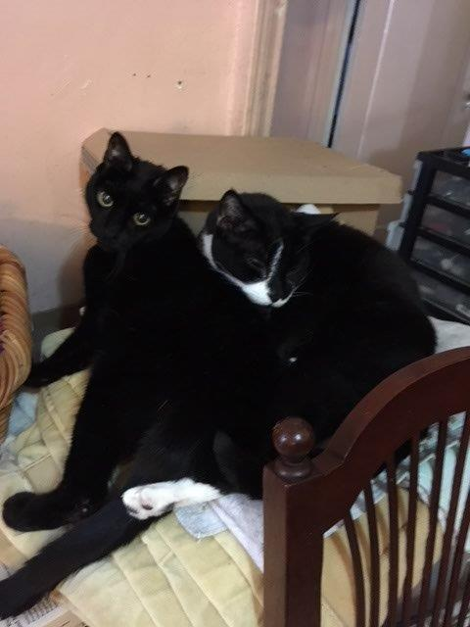
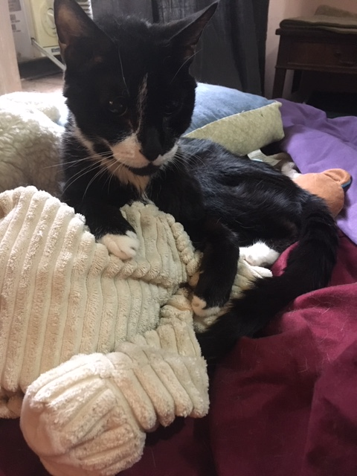
When the adopter was forced to rehome them, at an age approaching the senior threshold, the two lovebirds came to live with Amiga, and they lived happily together until, sadly, last year, Delilah became ill and passed away.

Millhauser, now fully into his senior self, has developed two of the most common elder kitty health issues, hyperthyroidism, as well as kidney disease. Since he is just at the beginning of these, we have been able to easily support him with the use of excellent nutritional supplements, Chinese herbal medicine, as well as acupressure massage.
This newsletter will introduce you to some of these nutrient supplements, as well as Chinese acupressure for small animal healing. In the future, we will continue to explore these topics.
Millhauser’s Senior Support Protocol:
- Acupressure Massage.
Beginning in March of this year, Millhauser began to suffer from some of the more distressing effects of “old age kidney.” Most troubling, he began to vomit frequently.
We have, in past years, experienced exceptional results with our animals through the use of acupressure massage, i.e. massaging “pressure points” as outlined in the Chinese meridian map of the body. We have found it easier to learn the basics of acupressure massage, as it is easier to be more readily hands-on with acupressure than it is to schedule acupuncture treatments, which give similar support.
Most pet parents will find it easy to learn a few of the basics of acupressure massage. There are some conditions, i.e. “bladder” (FUS) where acupressure massage is nothing less than a miracle adjustment!
We were able to help Millhauser achieve balance through the massaging of just three different pressure points over a period of days to help resolve some of the more troubling symptoms of his chronic kidney ailment.
Below are two links to online animal blogs that give descriptions on how to perform acupressure massage for healing the senior kidney problems many older cats face, as well as maps of the meridian points on the cat’s body and descriptions and locations of the points to massage.
The names of the pressure points to massage for kidney are: Bl23 (Bladder 23) on the spine about five vertebrae up from the hip socket and two points on the leg Ki3 (Kidney 3) and Sp6 (Spleen 6). (Bl23 is also the most important point to massage when treating a cat for symptoms of FUS.)
https://theloveofanimals.com/pet-therapies/accupressure-for-animals/acupressure-kidney-feline-disorder/
https://www.animalacupressure.com/blogs/animal-acupressure/feline-kidney-support-with-acupressure
The above described points are the points that were used on Millhauser, and, as well, we have occasionally massaged the “calming points” (Heart 7, Pericardium 7 and the Bai Hui point located between the two hip sockets) to relieve any stress Millhauser may have experienced during the onset of symptoms. These points are noted in the link below, which features a chart showing the “calming” points on the back of the spine and on the ankle bones.
https://animalwellnessguide.com/trip-to-the-vet-calming-cats-with-acupressure/
I am happy to report that this has been a very successful treatment for supporting Millhauser through the worst symptoms of senor kidney ailment!
- Nutrition and Supplements.
We believe that Millhauser’s hyperthyroid condition has benefitted from the acupressure massage techniques noted above. In addition, we have been able to support this condition with frequent feedings of high quality canned cat foods, mostly varieties of Wellness and, especially, Petguard. But, importantly, we have used substantive supplementation, which includes a most unique supplement, PDG, developed by Dr. Wysong for dogs and cats with appetite issues and who may be undernourished for one reason or another. (Available as a powder from Wysong.com, Chewy.com or Amazon.) And, though, there is a great availability on the supplement market of many high quality veterinary supplements for supporting chronic kidney problems in dogs and cats, we have successfully used “Kidney Restore,” also a powder, which can also be used for dogs.
It is important to note here that though we have some success in adding powder supplements directly to the wet canned food, our most effective way to deliver supplements and meds to cat or dog is by mixing it in a tablespoon or two of Gerber’s chicken flavor baby food! Every animal I have known loves this product and laps it up, no matter what healthy substance or med it is being used to disguise!
- Chinese Herbal Supplements.
There are currently quite a few good companies who now serve the veterinary market with Chinese herbs for animals – and, though, we have not committed to a complete survey -- we are currently using for Millhauser, a liquid Chinese herbal supplement from the company, Pet Wellbeing, which is recognized for quality products. The supplement we are using is Pet Wellbeing’s, “Kidney Support Gold,” which contains herbs we know (from previous human experience!) to be a positive support to kidney issues in both humans and, a mix obtained from three healing roots: Rehmannia, Cordyceps, and Astralagus.
Amiga Animal Rescue will continue to feature more in-depth explorations of Chinese medicine for animal health in future newsletters and e-books, and we encourage you to pursue your own study in the area of acupressure massage for your cat or dog. It is a very effective way to help your pet, and is a wonderful way for you and your pet to bond! In this area of healing, a little knowledge and practice goes a very long way toward healing and support. I am enclosing book and online resources here. And, although there are many fine resources available online and on Amazon on the topic of Veterinary Chinese Medicine, I am listing below a few that I have found especially helpful:

Four Paws, Five Directions: A Guide to Chinese Medicine for Cats and Dogs Paperback – July 1, 1996,by Cheryl Schwartz (Author), Mark Ed. Schwartz (Author)
animalacupressure.com (aka as “Tallgrass Animal Acupressure Resources”)

https://www.animalacupressure.com/pages/small-animal-acupressure

We invite you to forward our newsletter to your friends who you feel may benefit from the information we offer in our newsletter series. As mentioned previously, our earlier newsletters are posted on www.amigaanimalrescue.com. As we continue with Covid protocols throughout the country -- take care, stay safe, and hug your animal friends now more than ever! (Maybe even working in a few pressure point massages!)

Mary Ellen Hancock

(And, finally, on the last page, a bonus cute Millhauser pic, snuggling with Adonis! Yes, really – “Adonis”!)
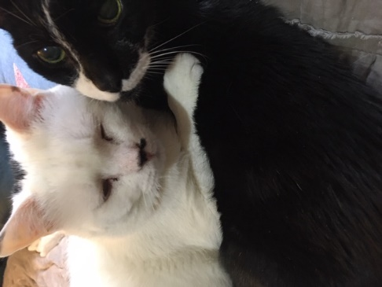

Amiga Animal Rescue is a 501©3 non-profit serving animals in New York. We also have a presence in Valencia County, New Mexico. You may donate to Amiga Animal Rescue using our PayPal donation button on our website, www.amigaanimalrescue.com, or you may also donate at www.gofundme.com/amigaanimalrescue. And our Go Fund Me donation page for our special rescue project, the “Sierra Project” is www.gofundme.com/f/amiga-animal-rescue039s-campaign-for-sierra. Your donations are tax deductible. Thank you for your help!

